CDC Bicycle Restoration System

Database System Project – Final Documentation
Course: | Database Systems
Quarter: | Spring 2026
Project Title: | CDC Bicycle Restoration Database
Organization / Client: | Contoso Donation Centers (CDC)
Student Name(s): | Esther Baretto, Felipe Malpica, Colton Lewis, Mija Dilberovic
Group Name: | Group B

Date Submitted: March 2026

Contoso Donation Centers (CDC) Database System
Table of Contents
1. Industry and Company Background 4
Company Background 4
Customers 4
Products and Services 4
Technology Environment 5
Participants / Employees 5
2. System Requirements 6
Scope and Objectives 6
Data Volume Considerations 6
Functional Requirements 6
Non-Functional Requirements 7
The database system must be easy to use so that employees with limited technical experience can operate it. Forms are designed to simplify data entry using dropdown lists and organized layouts. 7
3. Conceptual and Logical Design 7
Entities and Business Functions 7
Relationships and Business Rules 8
Assumptions 9
Required Queries and Reports 10
Entity Relationship Diagram (ERD) 14
Relational Model (Normalized) 14
4. Physical Design 16
Tables 16
Forms 17
Queries 19
Reports 22
EventVolunteerParticipation 22
5. Implementation Notes 24
Sample Data 24
Data Integrity 25
Security and Access Control 25
System Limitations 25
6. Future Enhancements 26
7. Summary and Conclusion 26
Student Certification 26

Industry and Company Background

Company Background

Contoso Donation Center (CDC) is a small non-profit organization that collects donated bicycles from the community and restored them for redistribution. CDC currently operates two locations: Contoso Main Donation Center West and Contoso Donation Center East. The organization relies on a combination of paid employees and community volunteers to restore bicycles through organized events.
CDC’s mission is to promote sustainability, community involvement, and access to reliable transportation by refurbishing donated bicycles and returning them to the community. As the organization continues to grow and plans to expand to additional locations, efficient data management and operational tracking have become essential.

Customers

CDC serves two primary groups: community donors and community members who ultimately receive restored bicycles. Additionally, internal users of the database system include employees and volunteers who require access to operational information.
The organization currently operated with approximately ten employees and rotating group of volunteers who participate in restoration events and training sessions. These users expect as easy-to-use system that allows accurate tracking of volunteer participation, training completion, event management, and bicycle restoration progress.

Products and Services

CDC provides bicycle restoration services through structured volunteer events. Donated bicycles are inspected, repaired, and restored to safe operating condition. Each bicycle is assigned a unique identifier and tracked through multiple restoration events if necessary.
In addition to restoration services, CDC provides volunteer training sessions covering topic such as brake repair, bike adjustment, and general maintenance. These training programs ensure that volunteers are properly prepared to participate in restoration events.

Technology Environment

CDC currently operates with limited technology and mostly manual record keeping. Volunteer participation, event attendance, and bicycle restoration progress are often tracked using spreadsheet or paper forms. While this works for a small organization, it becomes difficult to maintain accurate records as the number of volunteers, events and bicycles increases.
To improve efficiency, CDC requires a centralized database system that allows employees to manage volunteers, events, training sessions, bicycles, and employees in one place. The system should allow easy data entry through forms, quick access to information through queries, and reporting tools to summarize volunteer hours, event participation, and restoration progress.

Participants / Employees

CDC operates with approximately ten employees who oversee the restoration process, organize volunteer events, and manage donations. In addition to employees, the organization relies heavily on volunteers from the community who assist with bicycle repairs and restoration activities.
Most employees have basic computer skills but are not database experts, so the system must be simple and easy to use. The database interface uses forms with dropdown menus and navigation controls to allow users to enter and retrieve information without needing the technical knowledge of the database structure.

System Requirements

Scope and Objectives

The goal of the CDC database system is to manage and organize information related to volunteers, employees, bicycles, events, training sessions, and locations. The system allows CDC staff to track volunteer participation in restoration events, record employee involvement, manage training sessions, and monitor bicycle restoration progress.
The database provides a centralized system that improves record accuracy and allows staff to quickly access information about volunteers, events, and training activities. This helps the organization operate more efficiently and supports CDC’s mission of restoring bicycles and returning them to the community.

Data Volume Considerations

The database is expected to store information for approximately 10-20 employees, 100-300 volunteers, and multiple restoration events each month, Each event may involve multiple volunteers and employees, resulting in many records within the event participation tables.
The system will also store data about bicycles, training sessions, and locations. While the initial database size is relatively small, the design allows the system to expand as CDC grows and additional volunteers, events, and bicycles are added.

Functional Requirements

Users must be able to:
- Add, update, and delete volunteer records
- Record volunteer participation in restoration events
- Track employee participation in events
- Manage bicycle records and restoration progress
- Record volunteer training sessions
- Manage event details such as location, date, and subject
- View information using queries to summarize volunteer hours and event participation
- Generate reports that summarize important data for management

Non-Functional Requirements

The database system must be easy to use so that employees with limited technical experience can operate it. Forms are designed to simplify data entry using dropdown lists and organized layouts.
The system must maintain data accuracy and integrity using primary keys, foreign keys, and validation rules. Performance requirements are minimal because the database will be used by a small number of users and will store a moderate amount of data.
The design also allows the system to scale if CDC expands to additional locations or increases the number of volunteers and events.

Conceptual and Logical Design

Entities and Business Functions

Volunteer | Stores volunteer personal information and contact details
EmergencyContact | Stores emergency contact information for volunteers
Address | Stores location information used by volunteers or employees
Events | Stores restoration event information
VolunteerEvents | Tracks volunteer participation and hours worked at events
Employees | Stores employee information
EmployeeEvents | Tracks employee involvement in events
Trainings | Stores volunteer training sessions
Bikes | Stores bicycle inventory and restoration status
Locations | Stores event location information

Relationships and Business Rules

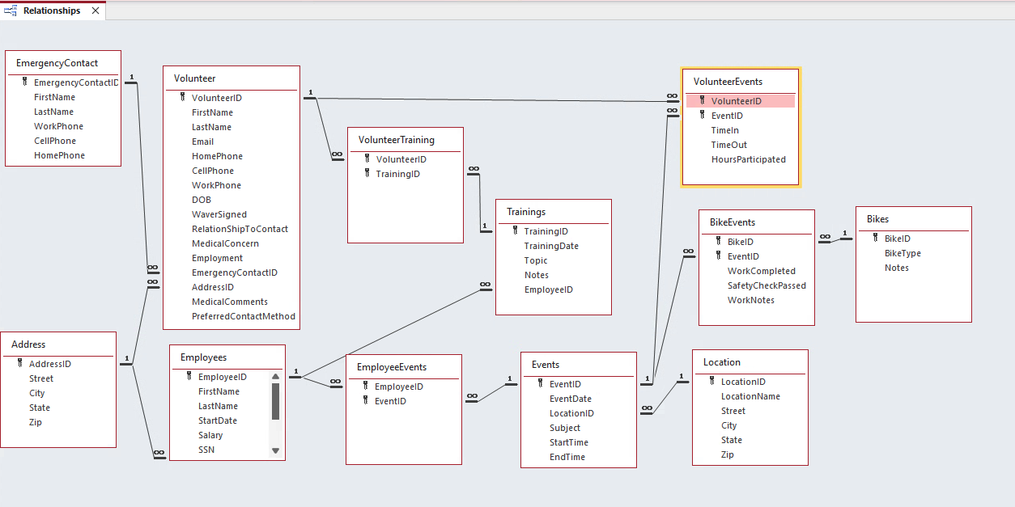

The CDC database system used several relationships to connect volunteers, employees, bicycles, and restoration events.
Each volunteer may participate in many restoration events. This relationship is implemented through the VolunteerEvents table, which records the volunteer identifier, event identifier, time-in, time-out, and total hours participated.
Employees may also participate in restoration events. This relationship is implemented through the EmployeeEvents table, which links employees to specific events.
Each event may involve multiple volunteers, employees, and bicycles. The BikeEvents table records the work performed on bicycles during each event, including whether the work was completed and whether the safety check was performed.
Volunteers may attend multiple training sessions, and each training session may include multiple volunteers. This many-to-many relationship is implemented through the VolunteerTraining table.
Emergency contact information is linked to volunteers using the EmergencyContact table. Each volunteer may have on emergency contact stored in the system.
Locations are used to store physical locations where restoration events take place.
These relationships ensure that the system can accurately track participation, restoration work, and training activities while maintaining data integrity through primary and foreign key relationships.

Assumptions

# Assumption Reason / Possible Impact
1 | CDC may operate multiple donation center locations where restoration events can take place. | The Location table allows the organization to expand to additional sites beyond the two currently used.
2 | Volunteers may participate in multiple events and events may involve multiple volunteers. | This many-to-many relationship is implemented through the VolunteerEvents table to accurately track participation and hours worked.
3 | Employees may assist with restoration events in addition to volunteers. | The EmployeeEvents table allows the system to track employee participation separately from volunteers.
4 | A bicycle may require work at multiple restoration events before being fully restored. | The BikeEvents table allows tracking of restoration progress across multiple events.
5 | Volunteers may attend multiple training sessions to improve repair skills. | The VolunteerTraining table supports tracking volunteer training history.
6 | Each event occurs at one primary location, but a location may host many events. | This supports efficient event scheduling while allowing CDC to expand operations to additional locations.
7 | Emergency contact information is stored for volunteers to ensure safety during restoration events. | This information may be used if a volunteer is injured or requires assistance during an event.

Required Queries and Reports

Name | Query/Report | Purpose
qryAG | Query | Displays volunteers whose first names begin with letters A–G, including training details, waiver status, and the employee responsible for the training.
qryBikeWorkReport | Query | Displays detailed information about bike work performed during events, including work completion status, safety check results, and repair notes for each bike.
qryEmployeeList | Query | Displays a list of employees including their names, start date, and salary details.
QryEventBikeCount | Query | Displays the relationship between events and bikes by listing which bikes were worked on during each event.
qryEventsList | Query | Displays all events with event date and location information.
qryEventTotals | Query | Displays a summary of each event by calculating the total number of volunteers and total hours participated.
qryEventVolunteerHour | Query | Displays detailed volunteer participation in events, including event date, time in/out, and total hours worked.
qryHL | Query | Displays volunteers whose first names begin with letters H–L, including training details, waiver status, and the employee responsible for the training.
qryMZ | Query | Displays volunteers whose first names begin with letters M–Z, including training details, waiver status, and the employee responsible for the training.
qryRecentTrainings | Query | Displays training sessions from the past 365 days, including training date, topic, and notes.
qryTrainingCountByEmployee | Query | Counts how many trainings each employee has conducted.
qryTrainingByEmployee | Query | Displays training sessions along with the employee responsible.
qryTrainingSchedule | Query | Displays all scheduled training sessions with date, topic, and notes.
QryVolunteerContactList | Query | Displays volunteer contact information including name, email, phone numbers, and address.
qryVolunteerEmergencyContacts | Query | Displays each volunteer with their emergency contact information.
qryVolunteerEventHours | Query | Calculates total hours each volunteer has participated in events.
qryVolunteerInformation | Query | Displays detailed volunteer information including personal and contact details.
QryVolunteerByCity | Query | Displays volunteers grouped by city.
qryVolunteersByEvent | Query | Displays volunteers participating in each event, including event name, date, time in/out, and hours worked.
QryVolunteerMedicalConcerns | Query | Displays volunteers who have medical concerns.
qryVolunteerTrainingHistory | Query | Displays each volunteer’s training history including date and topic.
EventVolunteerParticipation | Report | Displays all events and participating volunteers, including hours worked, total volunteers, and bikes restored.
rptAG | Report | Displays a check-in list of volunteers (A–G) including training and waiver status.
rptEventCompletion | Report | Displays work completed on bikes during events, including safety check status and repair notes.
rptEventWorkPerformed | Report | Displays detailed information about work performed on bikes during each event.
rptHL | Report | Displays a check-in list of volunteers (H–L) including training and waiver status.
rptMZ | Report | Displays a check-in list of volunteers (M–Z) including training and waiver status.
rptVolunteerContactList | Report | Displays a list of volunteers with their contact information.
rptVolunteerTotalHours | Report | Displays total hours contributed by each volunteer and overall totals.
rptVolunteerTrainingHistory | Report | Displays each volunteer’s training history including dates and topics.
SubBikeCount | Report | Tracks the number of bikes restored and supports other reports.

Entity Relationship Diagram (ERD)

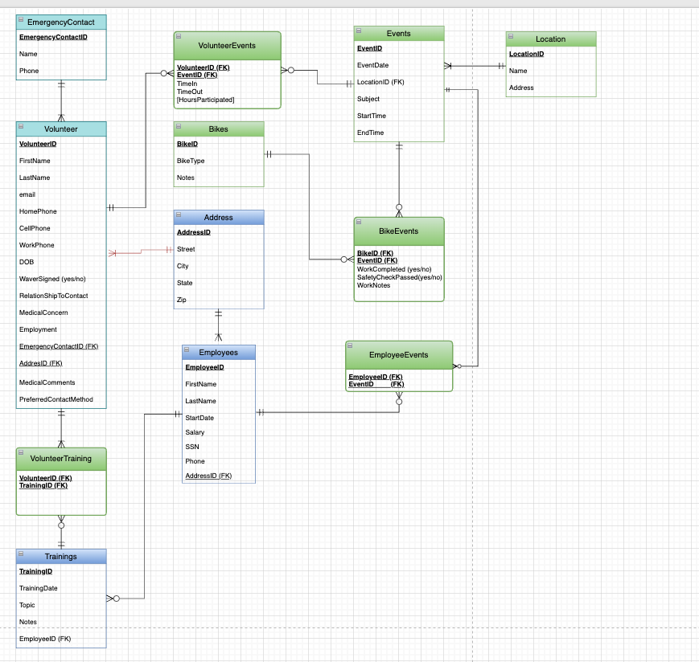

Relational Model (Normalized)

- Volunteer (VolunteerID PK, FirstName, LastName, Email, Phone, AddressID FK)
- EmergencyContact (ContactID PK, VolunteerID FK, ContactName, Phone)
- Address (AddressID PK, Street, City, State, Zip)
- Events (EventID PK, EventDate, LocationID FK)
- Location (LocationID PK, LocationName, AddressID FK)
- Employees (EmployeeID PK, FirstName, LastName)
- EmployeeEvents (EmployeeID FK, EventID FK)
- VolunteerEvents (VolunteerID FK, EventID FK, TimeIn, TimeOut, HoursParticipated)
- Trainings (TrainingID PK, TrainingDate, Topic, EmployeeID FK)
- VolunteerTraining (VolunteerID FK, TrainingID FK)
- Bikes (BikeID PK, BikeType, Notes)
- BikeEvents (BikeID FK, EventID FK, WorkCompleted, SafetyCheckPassed, WorkNotes)
The database structure is normalized to Third Normal Form (3NF) to eliminate redundancy and ensure data consistency.

Physical Design

Tables

Table Name | Primary Key | Foreign Keys
Address | AddressID | –
BikeEvents | – | BikeID, EventID
Bikes | BikeID | –
EmergencyContact | EmergencyContactID | –
EmployeeEvents |  | EmployeeID, EventID
Employees | EmployeeID | AddressID
Events | EventID | LocationID
Location | LocationID | –
Trainings | TrainingID | EmployeeID
Volunteer | VolunteerID | EmergencyContactID, AddressID
VolunteerEvents | – | VolunteerID, EventID
VolunteerTraining | – | VolunteerID, TrainingID

Forms

- frmAddress
Used to enter and update address information.
Maintenance includes editing and correcting address records.
- frmBike
Used to enter and update bike information.
Maintenance includes updating bike type and notes.

- frmBikeEvents
Used to record bike work performed during events.
Maintenance includes updating work status and safety check results.

- frmEmergencyContact
Used to enter and update emergency contact information.
Maintenance includes updating contact details.

- frmEmployeeEvents
Used to track employee participation in events.
Maintenance includes adding, updating, or deleting event assignments.

- frmEmployees
Used to manage employee records.
Maintenance includes updating employee details such as phone, address, and salary.

- frmEvents
Used to create, view, and manage event information, including volunteer participation and event details.
Maintenance includes adding, updating, or deleting event records and ensuring accurate event details and participation data.

- frmHome
Used as the main interface of the system, providing navigation access to forms, queries, and reports.
Maintenance includes updating the layout, images, or navigation elements as needed.

- frmQueries
Used to run and view query results.
Maintenance includes updating query selections if needed.

- frmTrainings
Used to manage training sessions.
Maintenance includes updating training topics, dates, and notes.

- frmVolunteer
Used to enter, view, and manage volunteer information, including personal details, contact information, and related training and event participation.
Maintenance includes adding, updating, or deleting volunteer records and ensuring accurate personal, contact, and participation data.

- frmVolunteerEvents
Used to track volunteer participation in events.
Maintenance includes updating time in/out and hours worked.

- frmVolunteerTraining
Used to track volunteer training participation.
Maintenance includes updating training records.

- Navigation Form
Used as the main interface of the system to organize and access different sections such as forms, queries, and reports.
Maintenance includes updating navigation options, layout, and links to ensure users can access different parts of the system.

Queries

- qryAG
Displays volunteers whose first names begin with letters A–G, including their training details, waiver status, and the employee responsible for the training.
- qryBikeWorkReport
Displays detailed information about bike work performed during events, including work completion status, safety check results, and repair notes for each bike.
- qryEmployeeList
Displays a list of employees including their names, start date, and salary details.

- QryEventBikeCount
Displays the relationship between events and bikes by listing which bikes were worked on per event.
- qryEventsList

Displays all events with event date and location information.

- qryEventVolunteerHours

Displays detailed volunteer participation in events, including event date, time in/out, and total hours.

- qryEventTotals
Displays a summary of each event by calculating the total number of volunteers and total hours worked.
- qryHL
Displays volunteers whose first names begin with letters H–L, including their training details, waiver status, and the employee responsible for the training.
- qryMZ
Displays volunteers whose first names begin with letters M–Z, including their training details, waiver status, and the employee responsible for the training.
- qryRecentTrainings

Displays training sessions from the past 365 days, including the training date, topic, and notes.

- qryTrainingCountByEmployee

Counts how many trainings each employee has conducted.

- qryTrainingByEmployee
Displays training sessions along with the employee responsible.

- qryTrainingSchedule
Displays all scheduled training sessions with date, topic, and notes.
- QryVolunteerContactList
Displays volunteer contact information including name, email, home phone, cell phone, and address.
- qryVolunteerEmergencyContacts
Displays each volunteer with their emergency contact information.
- qryVolunteerEventHours
Calculates total hours each volunteer has participated in events.
- qryVolunteerinformation
Displays detailed volunteer information including personal and contact details.
- QryVolunteerByCIty

Displays volunteers grouped by city.

- qryVolunteersByEvent
Displays volunteers participating in each event, including event name, date, time in/out, and hours worked.
- qryVolunteerMedicalConcerns
Displays volunteers who have medical concerns.
- qryVolunteerTrainingHistory
Displays each volunteer’s training history including date and topic.

Reports

EventVolunteerParticipation
This report displays information for all events and the volunteers who participated in each event. Each event is identified by its Event ID and Event Date.
It includes the following:
- Volunteer first and last name
- Time in and time out for each volunteer
- Total hours participated
- Number of bikes restored
- Total number of volunteers
- Total combined hours worked by all volunteers

rptAG
Report A-G is a Check in Report that displays a list of volunteers whose first names begin with letters A through G.
It includes the following:
- First and Last name of the volunteer
- Waiver Signed status
- Training Date
- Training Topic
- Employee ID of the person who conducted the training
- Total number of volunteers

rptEventCompletion
The Event completion report provides detailed information on the work performed in each
event. The report is organized by Event ID and Event Date.
For each bike it displays the following:
- Bike ID
- Bike Type (Mountain, Road, Kids, Hybrid, Cruiser)
- Work Completed Status
- Safety Check Passed Status
- Work notes describing the maintenance or repairs completed during the event

rptEventWorkPerformed
This report displays detailed information about all work performed on bikes during each event. It
is organized by Event ID and Event Date, grouping all related bike records under each event for
a clear and structured view. It includes the same information as the Event Completion report but
is formatted to present the data in a more organized layout.

rptHL
Report H-L is a Check in Report that displays a list of volunteers whose first names begin with letters H through L.
It includes the following:
- First and Last name of the volunteer
- Waiver Signed status
- Training Date
- Training Topic
- Employee ID of the person who conducted the training
- Total Number of volunteers

rptMZ
Report M-Z is a Check in Report that displays a list of volunteers whose first names begin with letters M through Z.
It includes the following:
- First and Last name of the volunteer
- Waiver Signed status
- Training Date
- Training Topic
- Employee ID of the person who conducted the training
- Total number of volunteers

rptVolunteerContactList
The Volunteer Contact List report provides a list of all volunteers and their contact information. The report includes each volunteers:
- First and Last Name
- Email Address
- Home Phone number
- Cell Phone Number
- City of residence

rptVolunteerTotalHours
This report lists each volunteer’s first and last name along with the total number of hours they have contributed. It also includes a summary of the total hours contributed by all volunteers.

rptVolunteerTrainingHistory
This report displays each volunteer’s name, the date of each training session, and the topic covered during that training.

5. Implementation Notes

Sample Data

The sample data for the CDC Bicycle Restoration System was curated to represent a realistic operational cycle. It includes a diverse set of volunteer profiles, varying skill levels for training sessions, and detailed inventory of bicycle types. This data demonstrates the system’s ability to handle many-to-many relationships (such as volunteers attending multiple events) and ensures that all queries and reports generate meaningful output for management.

Data Integrity

Data integrity is strictly enforced though a multi-layered approach within MS Access:
- Entity Integrity: Primary keys are defined for every table to ensure unique identification of records.
- Referential Integrity: Enforced on all relationships with “Cascade Update” enabled to prevent orphaned records (e.g., ensuring a volunteer cannot be assigned to an event that does not exist).
- Automated Primary Keys: The use of AutoNumber for all Primary Keys (e.g., VolunteerID, EventID) ensures that entity integrity is maintained without requiring manual, error-prone ID entry from the user.

Security and Access Control

The system is designed with a user-centric security model. To protect the integrity of the underlying data structures, the database utilizes a Custom Navigation Form as the primary interface. By setting this form to launch automatically upon startup, standard users are directed away from the “All Access Objects” pane, preventing accidental modification of table relationship logic. This ensures that data entry is performed only trough controlled, pre-defined interfaces.

System Limitations

The current system is a desktop-bases solution optimized for local network use. It does not currently support real-time web-based synchronization or mobile device integration. Additionally, while the system track volunteer hours, it does not include built-in payroll module for paid employees, as the current scope focuses exclusively on volunteer management and bicycle inventory.

6. Future Enhancements

Potential future enhancements:
- Automated Email Reminders: Integration with Microsoft Outlook to automatically send appointment reminders to volunteers.
- Advanced Data Validation (Input Masks): Implementing standardized Input Masks for all Phone and Zip Code, which reduces data entry errors and improves report professionally.
- Attachment Storage for Waivers: Transitioning the Waiver Signed checkbox to an attachment field type. This would allow the organization to upload and store a digital scan of the physical signed document directly within the Volunteer record for legal compliance.

7. Summary and Conclusion

The CDC Bicycle Restoration Database successfully meets all established business requirements and project objectives. By moving from manual tracking to a centralized relational database, the organization can now accurately track volunteer contributions, manage bicycle inventory, and generate professional reports with a single click. The system provides a scalable foundation that will allow Contoso Donation Center to grow their community impact through better data-driven decision-making.

Student Certification
By submitting this document, I certify that this work reflects my (or our group’s) original effort and that all design decisions are documented accurately.
Student Name(s): Mija Dilberovic, Esther Baretto, Felipe Malpica, Colton Lewis
Signature(s):
Date: March 20, 2026

